**Steps to import acadgild vm:**

1.Open the virtual box and then follow the below steps:

**Click on File --**→ **Import Appliance.** 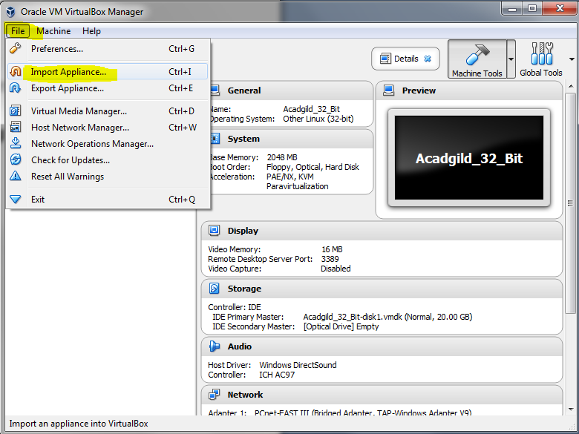

2. **Click on the Folder option as shown in the below screenshot to browse to the location where hadoop vm is present.** 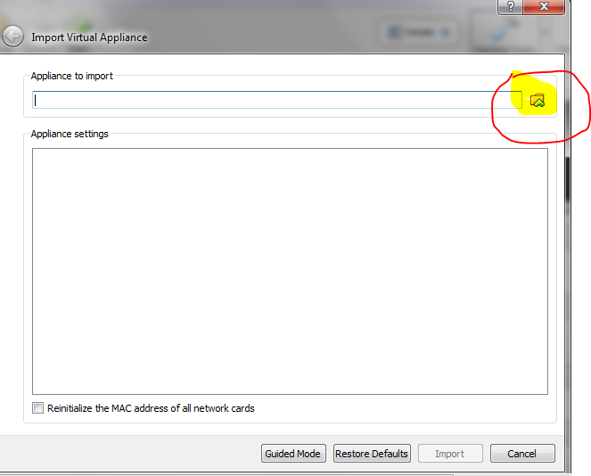

**3. Select the VM to be imported an then click on Open button.**

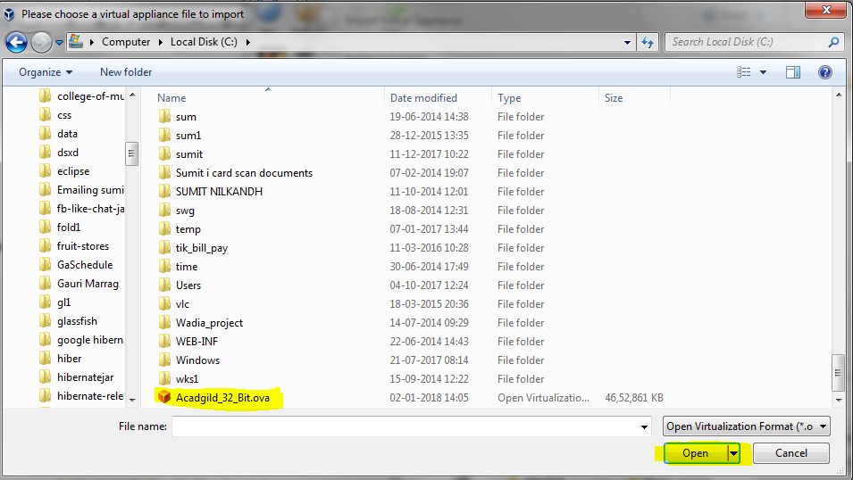

**4. Click on Import to proceed to next step:**

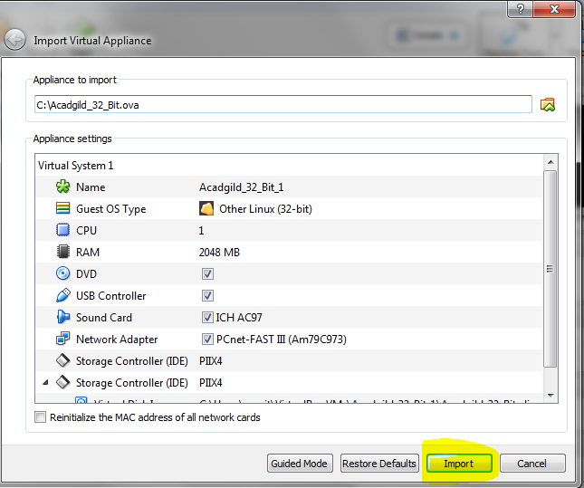

**5. Once the vm starts getting imported it gives a prompt as shown below:**

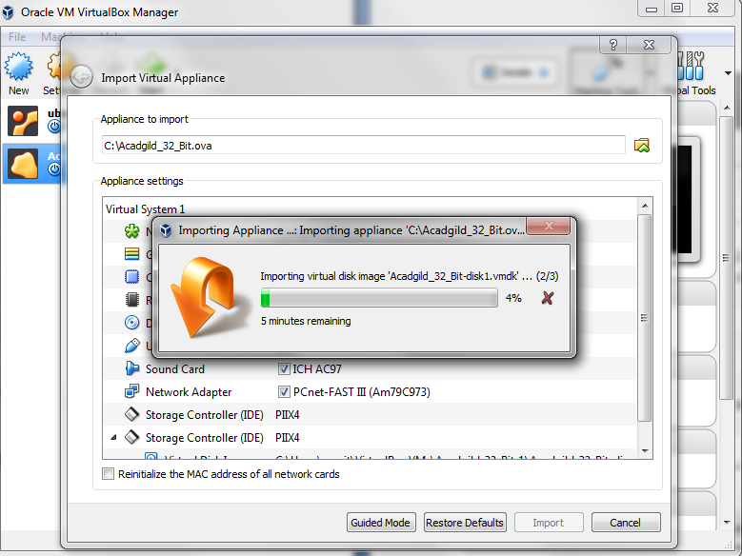

**6. Once the importing gets finished, we need to click on the start button as shown in the below screenshot:**

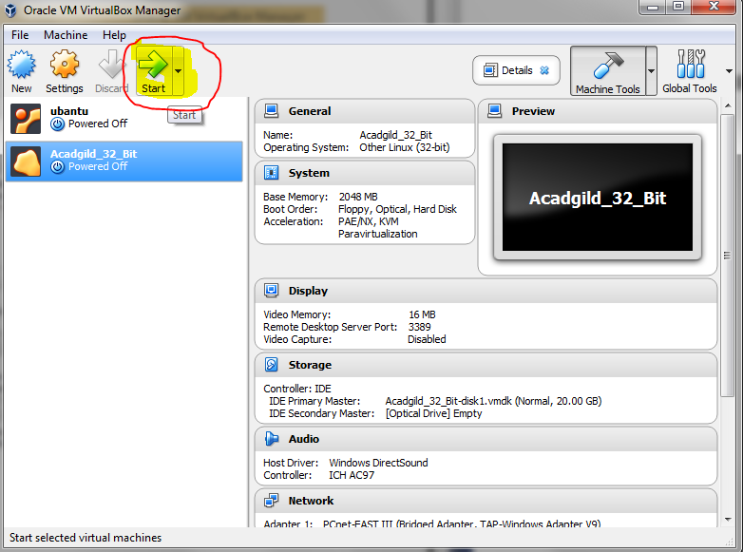

**7. We need to give the password as acadgild.**

**Password: acadgild**

